**Effective communication of online classes   
through hand gesture recognition**

**Team Brnology**

Cho Junhee

Kim Kyumin

Elvis Juma

Kim Hyoeun

**1.Intro**

With the arrival of Covid-19, Most of the students are taking online classes using programs such as Zoom and Google Meet. For that reason, It is not easy to meet the needs of students. In order to better accommodate their needs,Our team is trying to solve this through hand gesture recognition. Hand gestures will be used to meet the needs of the students in class. For example, if a student asks a question, can’t hear the voice well, or the ppt is difficult to read.Because we plan to recognize students' hands through real-time images, learning will be conducted using webcams. The tools we used are Mediapipe, Numpy and OpenCV. By using this technology, it is expected that students will be able to create a high-quality class atmosphere by increasing their concentration.

**2. DataSet**

 

**- We collected data our own from**

**students in machine learning class.**

**3. Library**

: OpenCV , Mediapipe, Numpy, Tensorflow, Smtplib

**4. How to approach & Task**

1. **collecting data our own from students in machine learning class.**

* using 21 landmarks for detecting a hand. We call Those landmark ‘JOINT’.
* compute angles between joints using joint vectors. array v2 - v1 shows Making joint vectors.

**※ gestures we made**

* **Question :** wave our hands
* **I can’t hear** : take your hand to your ear and make it in the shape of your ear
* **I can’t see**: make a circle with your thumb and index finger, and open the rest of your fingers.

1. **Data preprocessing** : Data Labeling, Data Classification
2. **Making Training model**: LSTM, Dense

* activation = relu, optimizer = adam
* split data into train-set and test-set

1. **Test** - see each gesture working well, check evaluation graph, confusion matrix
2. **Event** - send an email which contains how many times gesture ‘Question’, ‘i can’t hear’ and ‘i cant see’ have been done.

**5. Accuracy**

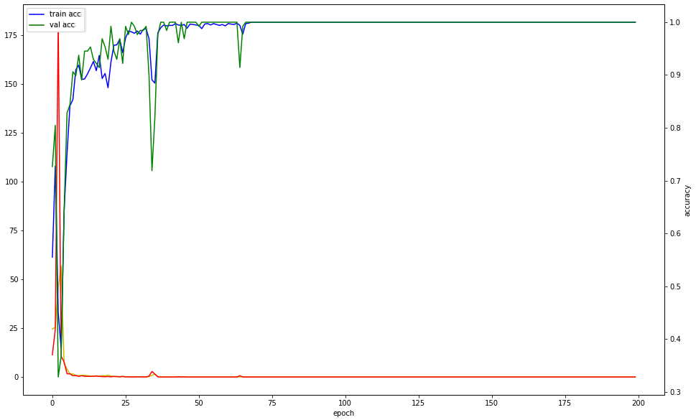

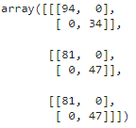

**6. code**

[**https://drive.google.com/drive/u/0/folders/1wS_6w94AMrm-S8uolbA0kho7jWB4n3pH**](https://drive.google.com/drive/u/0/folders/1wS_6w94AMrm-S8uolbA0kho7jWB4n3pH)

**7. result**

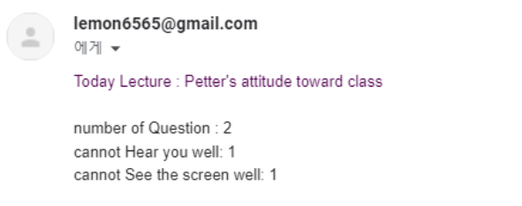

At the end of the class, we will send an email about how many times each gesture has been performed. It will help the professor to improve the lecture(or fix things). For example, if there are a lot of ‘I can’t hear’ gestures, professor can turn up the volume of the microphone or check what kind of problems there are.